Project Title | Video Game Sales and Engagement Analysis
Skills take away From This Project | Python, Power BI, Data Cleaning, SQL, Data Visualization, Exploratory Data Analysis (EDA)
Domain | Gaming and Entertainment Analytics
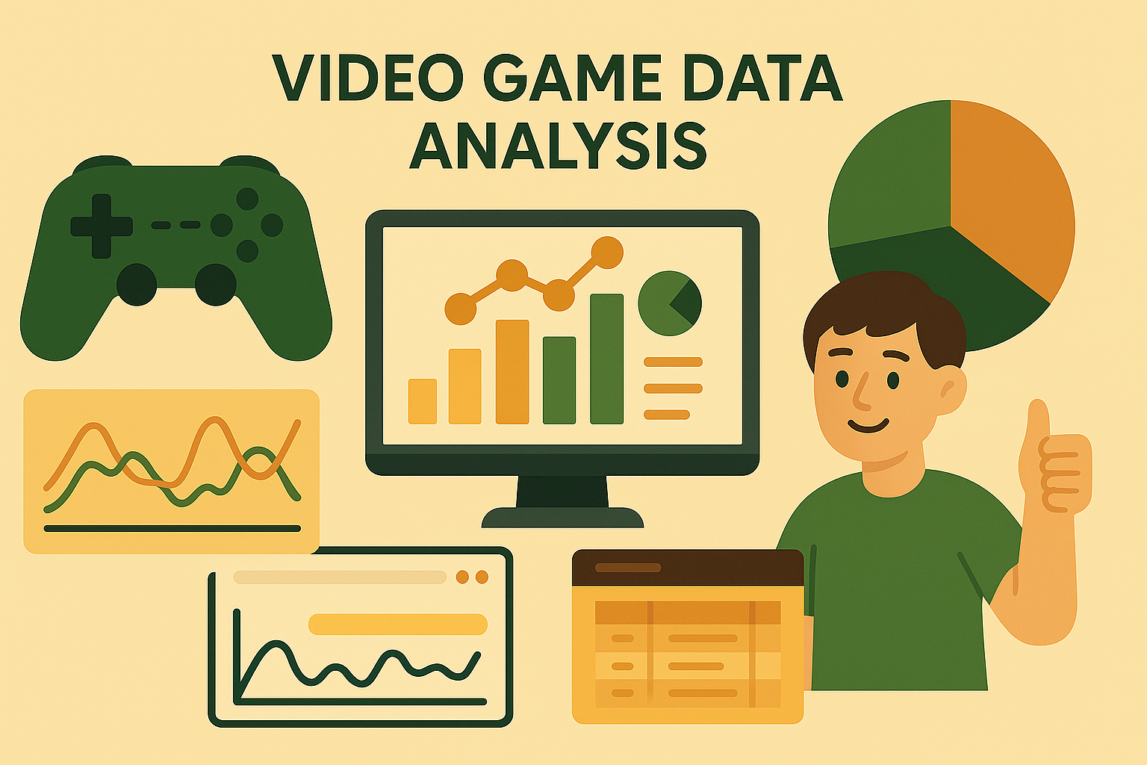
Problem Statement
The project aims to analyze and visualize video game sales and engagement data to uncover trends in game popularity, user behavior, and platform performance. By merging sales and engagement data, we seek to offer insights into how game features, platforms, and genres influence sales, wishlists, and ratings. SQL will be used to structure and store the data, while Power BI dashboards will be developed to guide decision-making for game developers, marketers, and publishers.

Business Use Cases
Game Marketing Strategy:
- Identify high-performing genres and platforms to target marketing efforts.
- Analyze rating and wishlist trends to understand user preferences.
Product Development:
- Evaluate how different game attributes (e.g., rating, genre, developer) relate to sales and engagement.
- Determine the features that correlate with successful game launches.
Sales Forecasting:
- Analyze past performance to forecast game demand.
- Evaluate the impact of game ratings and wishlists on global sales trends.
Resource Allocation:
- Focus development on platforms and genres with proven commercial success.
- Detects regions or genres with lower saturation and high opportunity.

Approach
1. Data Cleaning:
- Remove duplicates and handle null values in ratings, plays, and sales.
- Normalize genre, platform, and publisher names.
- Standardize formats for date and categorical fields.
2. SQL Database Setup:
- Create structured tables for game metadata, sales data, and merged information.
- Enforce foreign keys to maintain referential integrity.
3. Power BI Integration:
- Connect Power BI to the SQL database.
- Import relevant tables and create relationships.
- Build dynamic dashboards using filters, slicers, and drilldowns.
4. Data Visualization in Power BI: Create interactive reports that include:
- Bar charts: Top genres, publishers, and platforms.
- Heatmaps: Global sales and regional breakdowns.
- Line charts: Sales and wishlist trends over time.
- Scatter plots: Ratings vs. sales or wishlist.
- KPI indicators: Average rating, total plays, top-performing genres.
5. Exploratory Data Analysis (EDA): Use Python or Power BI to:
- Analyze ratings, plays, wishlists, and sales trends.
- Explore genre and platform popularity.
- Identify key success factors for high-selling games.

Dataset
- Dataset 1: games.csv
- Dataset 2 : vgsales.csv
Dataset Description
1. games.csv (Game Engagement Data)
- Title: Game name.
- Rating: User review score (numeric).
- Genres: Game categories (can be multiple).
- Plays: Number of playthroughs.
- Backlogs: Number of users who plan to play it.
- Wishlist: Number of users who wishlisted the game.
- Release Date, Platform, Team (Developer).
2. vgsales.csv (Sales Data)
- Name: Game name.
- Platform: Console or device.
- Year: Year of release.
- Genre: Main category.
- Publisher: Game publisher.
- NA_Sales, EU_Sales, JP_Sales, Other_Sales, Global_Sales: Sales by region.

Exploratory Data Analysis (EDA)

✅ Answerable Questions (in Power BI)

📁 games.csv (Game Metadata Only)
- 🌟 What are the top-rated games by user reviews?
- 🧑‍🤝‍🧑 Which developers (Teams) have the highest average ratings?
- 🧩 What are the most common genres in the dataset?
- ⏳ Which games have the highest backlog compared to wishlist?
- 🗓️ What is the game release trend across years?
- 🔎 What is the distribution of user ratings?
- 🧑 What are the top 10 most wishlisted games?
- 🔬 What’s the average number of plays per genre?
- 🏢 Which developer studios are the most productive and impactful?

💰 vgsales.csv (Sales Data Only)
- 🌍 Which region generates the most game sales?
- 🕹️ What are the best-selling platforms?
- 📅 What’s the trend of game releases and sales over years?
- 🏢 Who are the top publishers by sales?
- 🔝 Which games are the top 10 best-sellers globally?
- 🧭 How do regional sales compare for specific platforms?
- 📈 How has the market evolved by platform over time?
- 📍 What are the regional genre preferences?
- 🔄 What’s the yearly sales change per region?
- 🧮 What is the average sales per publisher?
- 🏆 What are the top 5 best-selling games per platform?

🔁 Merged Dataset (Sales + Engagement + Ratings)
- 🎮 Which game genres generate the most global sales?
- 🎯 How does user rating affect global sales?
- 🕹️ Which platforms have the most games with high ratings (e.g., above 4)?
- 📈 What’s the trend of releases and sales over time?
- 🧍 Do highly wishlisted games lead to more sales?
- 🎮 Which genres have the highest engagement but lowest sales?
- 🧠 Do highly listed games (wishlist/backlogs) correlate with better ratings?
- 🏷️ How does user engagement differ across genres?
- 🎉 What are the top-performing combinations of Genre + Platform?
- 🌐 What does a regional sales heatmap by genre reveal?

Results: By the end of this project, learners will achieve:
- A clean, SQL-structured database for video game data.
- Power BI dashboards with multiple interactive charts and KPIs.
- Data-driven insights on genre success, platform preferences, and consumer behavior.

Project Evaluation Metrics
Data Cleaning Process:
- Handling of missing and inconsistent values.
- Accuracy and consistency in categorical fields.
SQL Database Quality:
- Normalization and data structure design.
- Use of primary and foreign keys.
Power BI Visualization Quality:
- Clarity, interactivity, and usability of dashboards.
- Appropriate chart types and slicer usage.
Insights and Actionability:
- Relevance of findings for marketing and development decisions.
- Ability to support strategy through data.

Technical Tags:
Python, Power BI, SQL, Data Cleaning, Game Analytics, Data Visualization, Sales Forecasting, Genre Analysis.

Project Deliverables:
- Source Code: Python code for preprocessing and SQL scripts.
- SQL Database: Structured and cleaned tables.
- Power BI Reports: Interactive dashboards and visual reports.
- Documentation: Process notes, insights, and screenshots of dashboards

Timeline:
Check your mail for the submission deadline of the project.
References:

Project Live Evaluation Metrics | Project Live Evaluation
EDA Guide | Exploratory Data Analysis (EDA) Guide
Capstone Explanation Guideline | Capstone Explanation Guideline
GitHub Reference | How to Use GitHub.pptx
4) HOW TO ESTABLISH SQL CONNECTION: | PYTHONSQLCODE_TAMIL.ipynb
Power BI tutorial: | PPB - The Ultimate Power BI
POWERBI_MYSQL_CONN_ISSUe | POWERBI_MYSQL_CONN_ISSUE  .NET_Connector(8.0.32)Error_Fix
Project Orientation (English) | Project Orientation Session : Video Game Sales and Engagement Analysis(English)
Project Orientation (Tamil) | video_game_analysis_Tamil.mp4
Project Excellence Series: Guided Learning & Problem Solving [EDA](English) | Project Excellence Series: Guided Learning & Problem Solving [EDA](English)
Project Excellence Series: Guided Learning & Problem Solving [EDA](Tamil) | Project Excellence Series: Guided Learning & Problem Solving [EDA](Tamil)

PROJECT DOUBT CLARIFICATION SESSION ( PROJECT AND CLASS DOUBTS)

About Session: The Project Doubt Clarification Session is a helpful resource for resolving questions and concerns about projects and class topics. It provides support in understanding project requirements, addressing code issues, and clarifying class concepts. The session aims to enhance comprehension and provide guidance to overcome challenges effectively.
Note: Book the slot at least before 12:00 Pm on the same day

Timing: Monday-Saturday (4:00PM to 5:00PM)

Booking link :https://forms.gle/XC553oSbMJ2Gcfug9
ss
LIVE EVALUATION SESSION (CAPSTONE AND FINAL PROJECT)

About Session: The Live Evaluation Session for Capstone and Final Projects allows participants to showcase their projects and receive real-time feedback for improvement. It assesses project quality and provides an opportunity for discussion and evaluation.
Note: This form will Open only on Saturday (after 2 PM ) and Sunday on Every Week

Timing:
For DS and AIML
Monday-Saturday (05:30PM to 07:00PM)

Booking link : https://forms.gle/1m2Gsro41fLtZurRA

Evaluation Metrics : Project Live Evaluation

Project Created By | Verified By | Approved By
Vinodhini | Shadiya P P | Nehlath Harmain

